Problem Statement & Solutions
Ambient Systems provides comprehensive climate management solutions for indoor environments.
Ambient’s vision is to create safe, healthy, and productive indoor environment for everyone by leveraging internet-of-things (IoT) and machine learning technologies.

Top five pain points of property owners and building operators across building types:
- Hard to find trained personnel to continuously manage building’s indoor environment
- No or minimal visibility into real-time environmental parameters
- Outdated and incompatible legacy systems
- Competing priorities (e.g., improve environmental parameters or reduce energy costs)
- Evolving legal compliance and certification requirements
Solution
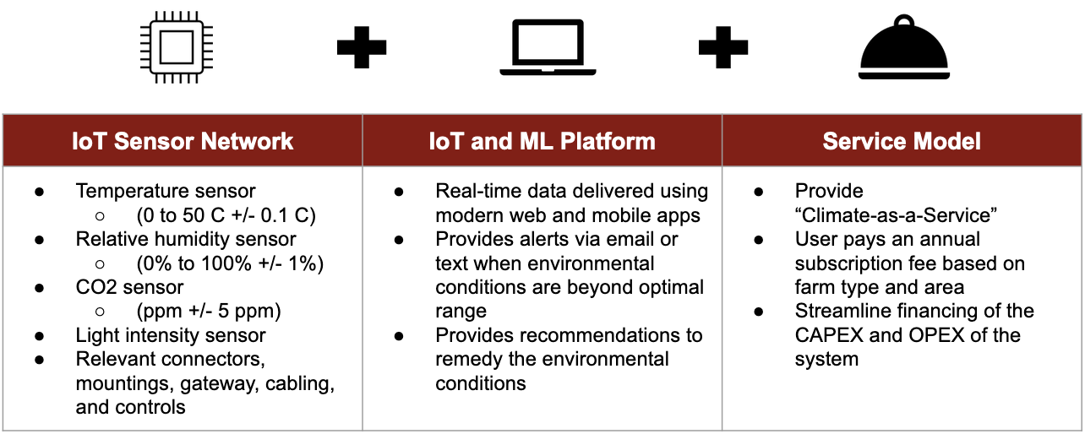

Competitive Advantage
- Integrated hardware-software design
- Streamlined service delivery
- Innovative business model

Intellectual Property
- Confidential

Partners
- Confidential

Timeline and Milestones

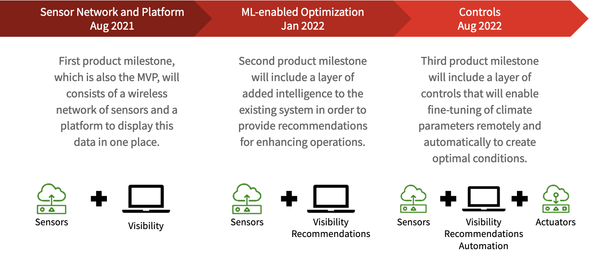
Market Potential
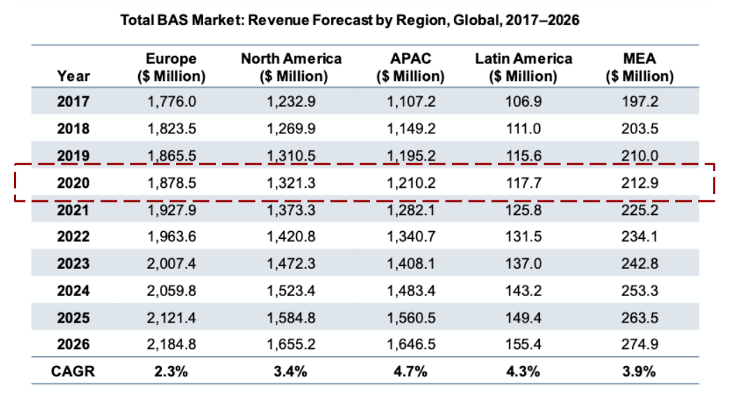

Revenue Model
- Subscription Fee (Climate-as-a-Service powered by ML)
- Implementation Fee (Installation & Integration)
- System Maintenance Fee (Hardware Upgrades)

Funding & Financing
- Confidential

Team Profile
- Ivan Damnjanovic, Founder
- [Third party], Mentor (Commercial Champion)
- [Team member], Venture Manager
- [Third party], Tech Manager

Contact: ivan@ambientsystems.ai

